|  |
| --- |
|  |



**19 October 2012** **The Weekly Bulletin of Rotary Club of Kathmandu Mid-Town** **Bc-19.10/012-13**

District : 3292 Web:www.rotarymidtown.org.np Club Id : 26776

**OCTOBER IS VOCATIONAL SERVICE MONTH**

The policy of Rotary with regard to business and professional relations among Rotarians is that a Rotarian should not expect or ask for more consid­eration or advantages from a fellow Rotarian than the latter would give to any other business or professional associate. As an obligation to competitors and in the spirit of vocational service, a Rotarian shall not grant to a fellow Rotarian privileges that would not normally be accorded to others with whom the Rotarian has a business or professional relationship..

Friday, 12 October:

Guest speaker, Ms Catherine Sue Jenson, provided an interesting PP presentation on Scheer Memorial Hospital, Banepa/Nepal, beginning from early start to present and also going a little further on future: its current activities, services provided, community help and future programs, its constraints, past Rotary support and possible areas of cooperation in future.

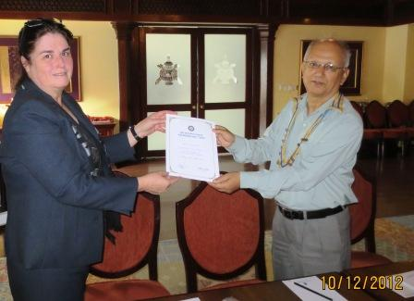

President Devendra handing over a certificate of appreciation to guest speaker

Ms. Catherine Sue Jenson, CEO of Scheer Memorial Hospital, Banepa

# Weekly Meetings and Programs :

|  |  |  |
| --- | --- | --- |
| Date | Program/Speaker | Program/Topics of Presentation |
| 19 Oct 2012 | Ms. Pramada Shah | Animal right |
| 26 Oct 2012 | ?? | ?? |
| 2 Nov 2012 | ?? | ?? |

Friday, 19 October:

Joint meeting with Rotary Club of Jawalakhel Manjushree.

Ms Pramada Shah, as the guest speaker, will be talking on “animal right”

**World Sight Day:**

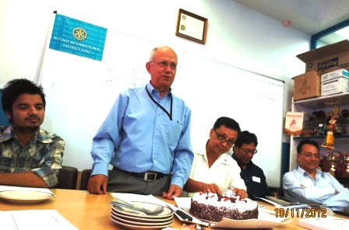

President Devendra , PP Anand, Rtn Buddha, PP Dr Chandra

Lekha and DRCC Kiran Lal Shrestha attended the  function of

Rotaract Club of Ktm Mid-Town held to observe the WORLD

SIGHT DAY by completion of targeted number of Vision

screening of over 10,000  school children in three and half

months.

**President Devendra speaking a few words**

**on the occasion.**

**Releasing Rotaracts’ e-Kaleidoscope, September 2012:**

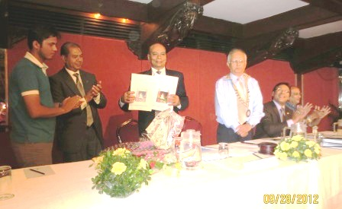

DG Yogendra Man Pradhan releasing September Issue e-Kaleidoscope,

a monthly bulletin of the Rotaract Club of Kathmandu Mid-Town

during the DG visit to the parent club after the official Club Assembly

on 28 September 2012.

**Changa Chait Champion:**



*It’s the Season to fly Kites*

Flying kites is an integral part of celebrating Dashain. To

revive this fast disapppearing art, The Club is holding out

annual  "CHANGA CHAIT"or KITE FLYING CONTEST.

This year too, Rtn Navyo has kindly offered to host this

event at his residence at Matatirtha.

Event date: Saturday, 20 October 2012

Timing: 13:00 to 16:00 hrs ( 1:00 PM to 4:00 PM)

Registration: Rs 300 per person (children free) to

subsidize cost of refreshments including drinks, and

unlimited supply of kites !

The best kite flying champion will be awarded *CHANGA CHAIT CHAMPION.*

**Positive Thinkers Enjoy Better Old Age, finds study:**

Growing old is an inevitable fact of life – but some people grow old, grumpy and disillusioned; while others retain a light-hearted, optimistic outlook and a youthful zest for life.

It may seem obvious that much depends on mental attitude - those who age best, maintaining a sunny outlook and a mind that gets sharper with age, are positive thinkers who avoid needless fret and worry. But now, a study by University of Hamburg scientists has found a scientific basis for this belief.

The study, published in the journal *Biological Psychiatry*, finds that those who age ''successfully'' have a positive outlook to life and prefer emotionally gratifying experiences.

It discovered that that focusing your brain on positive thoughts, and living for the moment rather than looking too far into the future, can help maintain good mental health.

The researchers studied the ''positivity effect'' by using neuro-imaging to evaluate brain engagement in young and old adults while they performed a specialised cognitive task that included supposedly irrelevant pictures of either neutral, happy, sad or fearful faces.

During parts of the task when they didn't have to pay as much attention, the elderly subjects were significantly more distracted by the happy faces.

When this occurred, they had increased engagement in the part of the brain that helps control emotions' and this stronger signal in the brain was correlated with those who showed the greatest emotional stability.

''Integrating our findings with the assumptions of life span theories we suggest that motivational goal-shifting in healthy aging leads to a self-regulated engagement in positive emotions even when this is not required by the setting," said lead researcher Dr Stefanie Brassen.

She defined the positivity effect as ''a biased tendency towards and preference for positive, emotionally gratifying experiences''.

The results of the study suggest that staying happy and focusing on life's positives are key to people remaining mentally alert as they get older.

Dr John Krystal, the editor of *Biological Psychiatry*, said, ''The lessons of healthy ageing seem to be similar to those of resilience throughout life.

''As recently summarised in other work by doctors Dennis Charney and Steven Southwick, when coping with extremely stressful life challenges, it is critical to appraise the situation realistically but also to approach it with a positive attitude.''

*I realized that the purpose of my life was not just to earn more, to sell more, to*

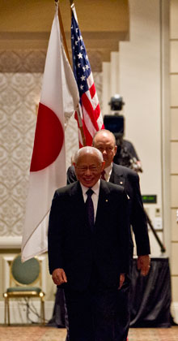

*make my business better than anyone else’s. I realized that I wanted to have higher*

*goals — both personally and professionally. I realized that for me, the most*

*important thing in life was being useful to other people.*

**RI President Sakuji Tanaka**

On Lighter Side :

Click here ⇩



**A THOUGHT FOR THE DAY:**

**Live as if you will die tomorrow; learn as if you will live forever.**

*courtesy:* Rtn Dr Isabella C Bassingana Khadka

**Great Quotes:**

***Opportunities are like sunrises,  
if you wait too long you can miss them.***

**A puzzle:**

***5 + 5 + 5 = 550****With a single stroke, prove the equation correct and get A+ score !*

NB: If you have any information/photo that may be of interest to Rotarians send them to

BC Editor: RR Shrestha email: rryesrr@gmail.com

## 19 Oct 2012 The Weekly Bulletin of Rotary Club of Kathmandu Mid-Town bc-19.10/012-13